Autumn 1 | Autumn 2 | Spring 1 | Spring 2 | Summer 1 | Summer 2
Getting to know you.  TEACHER ASSESSMENT & BASELINE ASSESSMENT  The assessment consists of: mathematics tasks, early number, early calculation (early addition/subtraction), mathematical language, early understanding of pattern  Routine  Numbers all around us  Counting  Just like me  Match and sort  Compare amounts.  Compare size, Mass and Capacity  Exploring pattern | It’s Me 1 2 3!  Representing 1, 2 and 3  Comparing 1, 2 and 3  Composition of 1, 2 and 3  Circles and Triangles  Positional language  Light and Dark  Representing numbers to 5  One more and less  Shapes with 4 sides  Time | Alive in 5!  Introducing zero  Comparing numbers to 5  Composition of 4 and 5  Compare Mass  Compare Capacity  Growing 6, 7, 8  6, 7 and 8  Combining 2 amounts  Making pairs | Length and Height  Time  Building 9 and 10  Counting to 9 and 10  Comparing numbers to 10  Bonds to 10  3D shapes  Patterns | To 20 and Beyond  Building numbers beyond 10  Counting patterns beyond 10  Spatial reasoning (1)  Match, Rotate, Manipulate  First Then Now  Adding more  Taking away  Spatial reasoning (2)  Compose and decompose | Find my Pattern!  Doubling  Sharing and grouping  Even and Odd  Spatial reasoning (3)  Visualise and build  On the Move  Deeping understanding  Patterns and relationships  Spatial reasoning (4)  Mapping
EYFS Maths Overview – White Rose
Mathematics ELG: Number Children at the expected level of development will: - Have a deep understanding of number to 10, including the composition of each number; - Subitise (recognise quantities without counting) up to 5; - Automatically recall (without reference to rhymes, counting or other aids) number bonds up to 5 (including subtraction facts) and some number bonds to 10, including double facts.
ELG: Numerical Patterns Children at the expected level of development will: - Verbally count beyond 20, recognising the pattern of the counting system; - Compare quantities up to 10 in different contexts, recognising when one quantity is greater than, less than or the same as the other quantity; - Explore and represent patterns within numbers up to 10, including evens and odds, double facts and how quantities can be distributed equally.

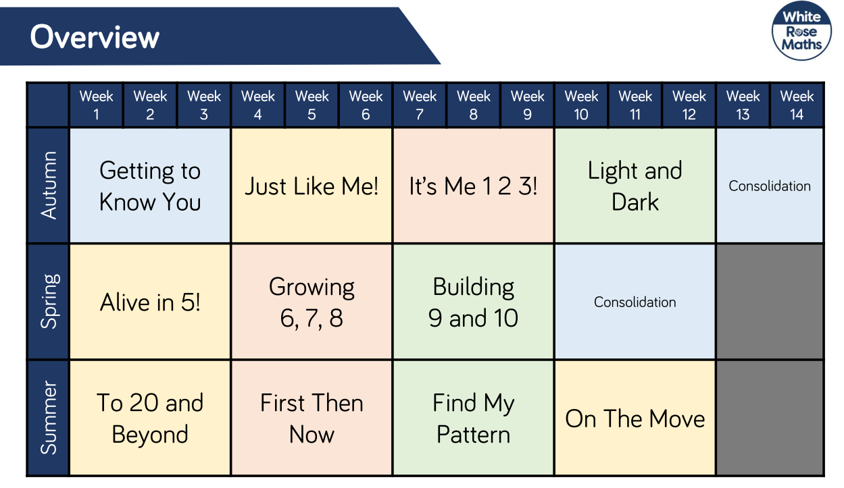

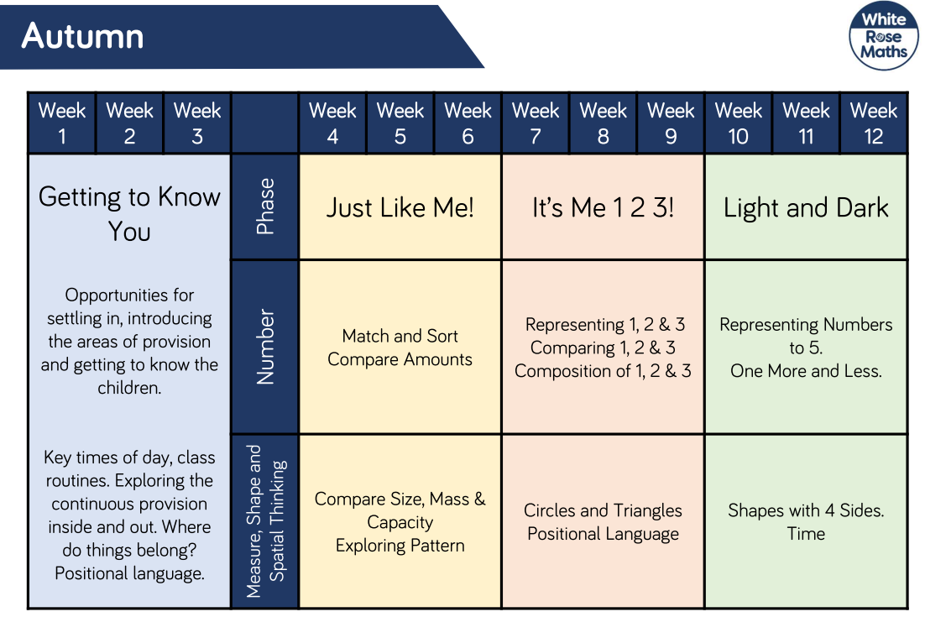
Autumn 1 | Week 1 | Week 2 | Week 3 | Week 4 | Week 5 | Week 6
 | Getting to know you |  |  | Just like me
 | Baseline and Teacher Assessment:  - Early Number  - Early Calculation  - Mathematical Language  - Early Understanding of Pattern |  |  | Focus: Match  Concepts and activities:  Find objects which are the same/different.  Play matching game (pairs).  Matching size and shape as well as pattern and colour.  Creating matching patterns (construction towers and kits)  Focus: Sort  Concepts and activities:  Sort into same/different – based on colour, size, shape.  Sorting into groups – sorting by own criteria.  Numberblocks  S1 E10 How to count | Focus: Compare Amounts  Concepts and activities:  Make comparisons to find groups have: equal/more/less/  greater/fewer  Focus: Compare size, mass and capacity.  Concepts and activities:  Compare and order based on size, mass and capacity.  Vocabularly  Large/small  Big/little  Short/tall  Tallest/shortest | Focus: Make simple patterns  Concepts and activities:  Copy, continue, make own simple repeating patterns (2&3 units of repeat)  Spotting mistakes in patterns.  Numberblocks  S3 E17 Pattern Palace
Settling:
Focus on getting to know the children. Learning about numbers around us. Daily routine, exploring number resources in provision, number rules for areas, postional language at tidy up time, playing games with friends. Daily counting, nursery rhymes and counting songs.
 | Activities to assist Baseline
 | My age.  My favourite fruit, animal, colour and count.  Matching fruit.  Patterns with favourite colours. | Pattern matching and counting using:  Rhyme – Five little ducks  Rhyme – Five speckled frogs  Rhyme – Five little men in a flying saucer | Positional language and sequencing using:  Rhyme – Humpty Dumpty  Sequencing daily events  Tidy up time  Sequencing meal times

Autumn 2 | Week 1 | Week 2 | Week 3 | Week 4 | Week 5 | Week 6 | Week 7
 | It’s me, 1, 2, 3! |  |  | Light and Dark
 | Focus:  Introducing 1, 2 and 3.  Concepts and activities:  Finding 1, 2 and 3 in the environment. Matching quantities to numeral.  Subitising images for 1, 2 and 3.  Introduce: circles and 1p  Rhymes/Stories  1, 2, 3, 4, 5 Once I caught a fish alive  Baa, baa, black sheep  Numberblocks  S1 E1 One  S1 E2 Another One  S1 E3 Two  S1 E4 Three | Focus:  Composition of 1, 2 and 3.  Concepts and activities:  Sorting different representations of 1,2 and 3  - Fingers  - Counters  - Cube towers  - Numicon  Seeing 3 in different ways – part-part-whole, partitioning and number bonds to 3.  Matching amounts to numerals.  One more and one less within 3.  Introduce: 2p  Numberblocks  S1 E5 One, Two, Three | Focus:  Circles and Triangles.  Concepts and activities:  Triangles and circles in real life.  Shape hunt  Describe shapes.  Make pictures with shapes.  Other maths activities:  Kandinsky’s Circles and Triangle images  Focus: Spatial Awareness  Concepts and activities:  Positional language | Focus:  Introduce 4 and 5.  Concepts and activities:  Making 4 and 5.  Introducing 5 frame.  Subitising 4 and 5.  Discussing/investigating number bonds to make 4 and 5.  Topmarks interactive game ‘Teddy counting’  Introduce: 5p  Rhymes/Stories  5 Current buns  5 Little men in a flying saucer  5 speckled frogs  5 red apples  5 Little ducks  Subitise song  Numberblocks  S1 E6 Four  S1 E7 Five  S1 E8 Three little pigs | Focus:  Exploring 4 and 5.  Concepts and activities:  Different ways 4 and 5 are made – verbally and describing.  Introducing five subitising frame.  Exploring shapes made with 4 and 5 cubes.  Focus: 1 more/1 less  Concepts and activities:  Using rhymes to explore one more and one less.  Exploring one more and less practically.  Rhymes/Stories  5 Little men in a flying saucer  5 green bottles  The enormous turnip  Numberblocks  S1 E11 Stampolines | Focus:  Rectangle and Squares.  Concepts and activities:  Rectangles and squares.  Describe features.  Finding shapes in real life and making pictures with 2D shapes.  Guess the shape in feely bag –  - Circle  - Triangle  - Square  - Rectangle  Shape Monster Topmarks interactive game.  Rhymes/Stories  Mr Strong (square)  Numberblocks  S1 E16 Flatland | Focus:  Night and day – time.  Concepts and activities:  Sequencing daily routines.  Time of day - day and night.  PSHE unit – Our day, sequencing getting ready for school/going to bed.  Rhymes/Stories  Peace at last.  Day monkey, night monkey.

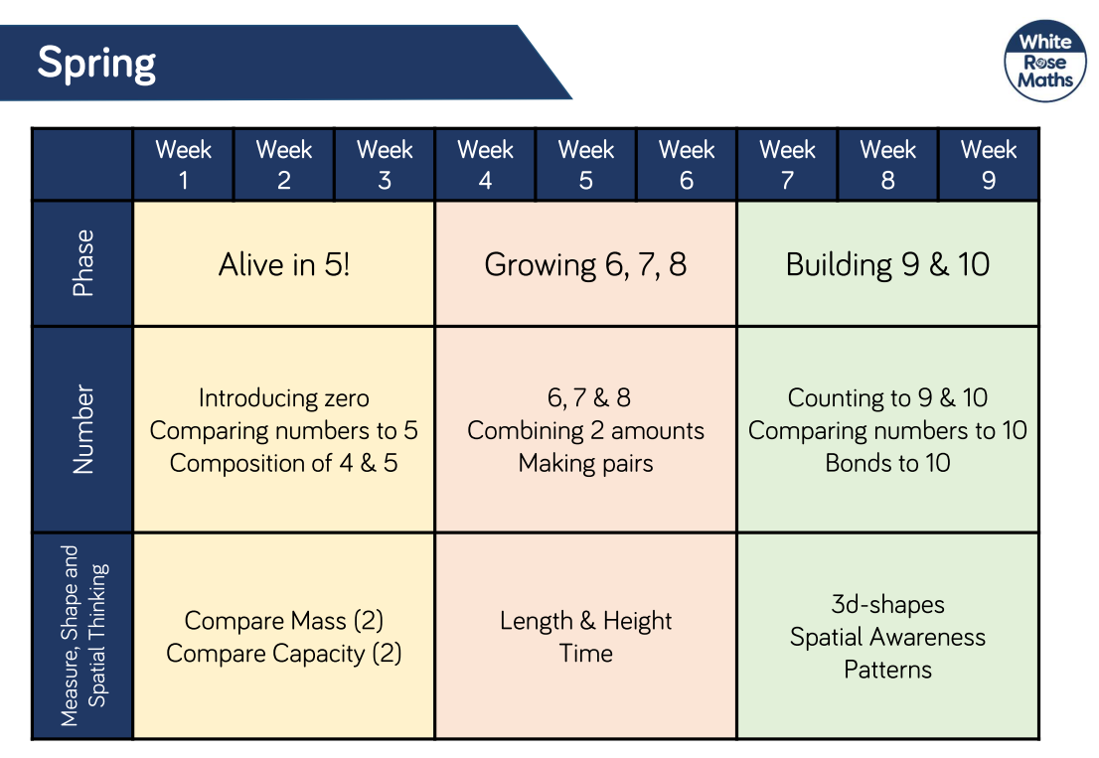

Spring 1 | Week 1 | Week 2 | Week 3 | Week 4 | Week 5 | Week 6 | Week 7
 | Alive in 5 |  |  | Growing 6, 7, 8
 | Focus:  One less.  Concepts and activities:  Sentence stems ‘one less than ___ is___’  Introduce: counting back from 5  Rhymes/Stories  5 currant buns  5 little ducks  (counting back – one less)  Focus: 0 Zero. Comparing numbers to 5.  Concepts: Quantities same/more/fewer than.  Equal and unequal groups.  Numberblocks  S3 E5 Zero  S3 E1 Once upon a time  S1 E12 The Whole of Me  S1 E14 Holes | Focus:  Composition of numbers to 5.  Concepts and activities:  Subitising.  Making pairs to make a whole.  Introducing part-part-whole method.  Number bonds to 5.  Addition and subtraction; 2 groups and 3 groups – how many altogether and how many missing?  Bunny ears – composition of 5.  Numberblocks  S1 E13 Terrible Twos  S3 E3 The Numberblocks Express  S1 E11 Stampolines  S1 E15 Hide and Seek | Focus:  Measuring and comparing mass and compacity.  Concepts and activities:  Using scales.  Heavier and lighter.  Full and empty.  How many fit inside?  Applying measuring and weighing into baking – biscuits, cupcakes. | Focus:  Introduce 6, 7 and 8.  Concepts and activities:  Subitising, comparing, part-part-whole of 6,7,8.  Introduce tens frame.  Rhymes/Stories  Six dinner Sid  Focus: One more and One less.  Concepts and activities:  How many are missing?  Add one more – how many now?  Numberblocks  S2 E1 Six  S2 E2 Seven  S2 E3 Eight | Focus:  Matching 6, 7, and 8.  Concepts and activities:  Matching images of 6, 7 and 8 in different representations  - Fingers  - Pictures  - Cube towers  - Double sided counters  - Ten frames  - Numicon  Focus: Pairs  Concepts and activities:  Pairing different resources.  Spotting one left over and ‘odd’.  Introduce: double 1, 2, and 3.  Rhymes/Stories  10 fat sausages  Numberblocks  S2 E12 Fluffies  S2 E9 Double trouble | Focus:  Combining groups and adding more.  Concepts and activities:  Count separate groups then how many together.  Adding more on a numberline.  Games with number tracks.  Numberblocks  S2 E6 Just Add One | Focus:  Length and height.  Time – Days of the week.  Concepts and activities:  Describe length and height (tall, taller, tallest, short, shorter, shortest, long, longer, longest)  Measuring height.  Measuring time.  Make direct comparisons.  Days of the week.  Focus: One minute – what can the children do in 1 min?  How many times can they write their name?  Can they fill a peg board?  How many jumps? Etc.  Rhymes/Stories  Jasper’s beanstalk  Big and Little  Jack Hartman Days of the week song

Spring 2 | Week 1 | Week 2 | Week 3 | Week 4 | Week 5 | Week 6
 | Building 9 and 10 |  |  | Consolidation
 | Focus: 9 and 10  Concepts and activities:  Comparing, representing, sorting 9 and 10.  Ordering numerals to 10.  Composition of 9 and 10.  - Double sided Counters  - Cube towers  - Ten frames  - Numicon  Topmarks interactive game ‘Under the sea counting’ and ‘Helicopter rescue’  Rhymes/Stories  Dr Nickaboka Number 9!  Numberblocks  S2 E4 Nine  S2 E10 The three threes  S3 E10 Hiccups | Focus: 9 and 10  Comparing numbers to 10  Concepts and activities:  Counting, comparing, sorting up to 10.  Using numberlines.  Composition of 10  - Ten frames  - Double sided counters  - Numicon  Bonds to 10, partitioning.  Counting forwards and backwards to 10.  One more/one less up to 10.  Rhymes/Stories  10 in a bed  10 green bottles  Numberblocks  S2 E5 Ten  S2 E7 Blast Off  S2 E7 Ten Green Bottles  S3 E6 Now we are 6-10 | Focus: 3D Shape  Concepts and activities:  Names of 3D shapes  - Cube  - Cuboid  - Sphere  - Cylinder  - Cone  3D fat shape/2D flat shape  Similarities/differences  Shape features – curved flat, corners  Identifying shapes in real objects.  3D shape hunt.  Printing with 3D shapes to identify 2D shape faces.  Building with 3D shapes.  Patterns – ABB, AABB Etc.  What’s my pattern.  Complete patterns  - Counters  - Glass beads  - Compare bears  Topmarks interactive game ‘Patterns’  Numberblocks  S3 E17 Pattern Palace  S3 E8 Building Blocks | Focus: Consolidating  Concepts and activities:  Sorting zero or not zero  Measuring  Equal and unequal  Composition of numbers up to 5.  One more/one less numbers to 5.  Subitising – dice games  Numberblocks  S3 E15 Ten Again | Focus: Consolidating  Concepts and activities:  Length and Height  Combining two groups  Numbers 6, 7, 8 compositions.  One more/one less numbers 6, 7, 8.  Numberblocks  S3 E9 Peekaboo!  S5 What’s my number?  S3 E14 Octoblock to the rescue! | Focus: Consolidating  Concepts and activities:  2D and 3D shapes  3D Sorting activities:  Roll/not roll  Curved/flat  Patterns  Number recognition to 10  Number bingo 0-10  Missing numbers  Numberblocks  S3 E13 Five and Friends  S2 E15 Numberblock castle  S3 E18 The legend of big tum.
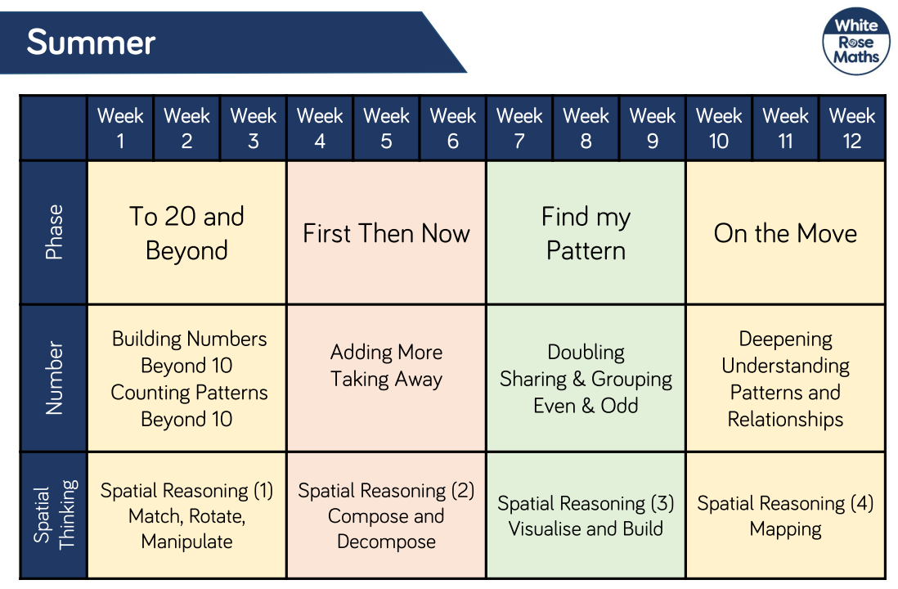
Summer 1 | Week 1 | Week 2 | Week 3 | Week 4 | Week 5 | Week 6
 | To 20 and Beyond |  |  | First, Then, Now
 | Focus: Building numbers beyond 10  Concepts and activities:  Number patterns to 20 (numbers 1-9 repeat after every full ten)  Understanding ‘teen’ numbers  Up to 20 on tens frames  Estimating  Matching pictures and numerals  Subtraction  Numberblocks  S3 E24 Eleven  S3 E25 Twelve  S3 E23  Ride the rays | Focus: Counting patterns beyond 10  Concepts and activities:  Visual representations of up to 20  - Fingers (with partner)  - Tens frames  - Numicon  - Cube towers  Counting patterns beyond 20 – 2,3,4 (5,6,7), 8,9,10 – number splat 100 square.  Counting along a numberline.  Ordering numbers to 20.  Bingo 0-20  Missing numbers.  Capacity and estimating  Numberblocks  S5 Ten Valuting  S3 E22 Black Star  S4 E11 Thirteen  S3 E26 Fourteen  S3 E27 Fifteen | Focus: Spatial Reasoning  Match, Rotate, Manipulate  Concepts and activities:  Matching shapes  Making shapes  - Peg boards  - Elastic band boards  - Lollipop sticks  - Pipe cleaners  Matching shapes with 3D models  Replicating models made with 3D and 2D shapes.  Tangrams with 2D shapes.  Numberblocks  S3 E28 Tween Scenes  S3 E30 Step squads  S4 Fifteen’s Minute of fame  S4 On your head | Focus: Adding More  Concepts and activities:  First, then, now stories – addition.  Adding more on ten frames  Adding more – unknown ‘then’.  Adding more ‘first’ unknown  Rhymes/stories:  Mr Grumpy’s Outing  Numberblocks  S4 Tens Place  S4 Balancing Bridge  S4 Sixteen  S4 Square Club | Focus: Taking Away  Concepts and activities:  First, then, now stories – subtraction.  Taking away with unknown ‘then’.  Playing games with numbers decreasing.  Rhymes/stories:  Kipper’s toybox  10 Green bottles  Numberblocks  S4 Seventeen  S3 Eighteen  S4 Loop the Loop  S4 Nineteen | Focus: Spatial Reasoning  Concepts and activities:  Making new shapes using right angled triangles, squares and triangles (folding/cutting)  Pattern blocks  Tangrams  Rhymes/stories:  Grandpa’s quilt  Numberblocks  S4 Twenty  S4 Tall stories  S4 Flights of fancy  S4 I can count to Twenty

Summer 2 | Week 1 | Week 2 | Week 3 | Week 4 | Week 5 | Week 6
 | Find my Pattern |  |  | On the Move
 | Focus: Doubling  Concepts and activities:  Doubling is ‘twice as many’.  Doubles on tens frames.  Building doubles with real objects.  Doubling using tens frames and mirrors.  ‘Double 2 is 4’  Introduce: Counting in 2s.  Numberblocks  S3 E19 Mirror, mirror  S4 Heist | Focus: Sharing and grouping  Concepts and activities:  Sharing equally between set number of people.  ‘Is it a fair share?’  Making equal groups.  Rhymes/stories:  The Doorbell rang  Numberblocks  S4 Sign of the Times  S4 Fun times  S4 The Lair of shares  S4 Terrible Twosdays | Focus: Evens and Odds  Concepts and activities:  Some things do not share equally into 2 groups and there is one left over.  ‘Is it a fair share?’  Identifying odd and even numbers.  Odd and even numbers on tens frames and Numicon.  100 square  Numberblocks  S2 E11 Odds and Evens | Focus: Problem solving  Concepts and activities:  Solve number problems using stories and scenarios up to 10.  Reinforce number bonds of all numbers to 10, especially 1 to 5.  Rhymes/stories:  Mr Grumpy’s Outing  Harry and his bucketful of Dinosaurs  Consolidation:  Number recognition to 20  Accurate counting | Focus: Patterns and relationships  Concepts and activities:  Investigating relationships between numbers and shapes – base 10, Numicon  Copy, continue and create repeating patterns (up to 4 steps) and symmetrical constructions.  Symmetry – mirrors.  Consolidation:  2D flat shapes  3D fat shapes | Focus: Spatial Reasoning  Concepts and activities:  Making maps of journeys – obstacle course, from stories, familiar journeys  Prepositional language  Introduce: left and right  Rhymes/stories:  Little Red Riding Hood  Handa’s surprise  Consolidation: Composition of numbers 10  Counting beyond 20.  Odd/even  One more/one less numbers to 10.

