Design Technology -Long Term Planning
Design Technology | Hillfort Specific | Cultural Isolation  Children at Hillfort may not be as familiar with different cultures as more multicultural locations. | Economic Isolation  Children at Hillfort may not have experienced some of the most current up to date technology that children in more cosmopolitan areas have. |  | Closing the vocabulary gap  There is a vocabulary gap at Hillfort that is being addressed. Children need to understand the words that they are using. | Oracy and articulating own opinions  Children at Hillfort need to practice articulating and justifying their own opinions and thoughts.
 | Design Technology Concepts | Creative, technical and practical expertise  Children need to perform everyday tasks confidently and participate successfully in an ever increasing technological world. | Build and apply  Children need technological knowledge, understanding and skills to create high-quality prototypes and products. | Critique, evaluate and test  Children need to be able to test theirs, and others, ideas and products. | Principles of nutrition  Children need to understand and apply the principles of nutrition and learn how to cook. | Consequence and impact  Children need to understand how technology has changed our lives and that people lived before there was the technology that they use today.
 | Design Technology Skills | Designing Skills | Understanding contexts, users and purposes  Children will use design criteria completing background research to support them where appropriate. They will be able to describe features of their work, who their work is designed for and how it works.
Generating, developing, modelling and communicating ideas
Children will generate ideas based on their own experiences, needs of the user and research.
 |  | Making Skills | Planning  Children will be able to order the stages of making, select appropriate tools and equipment and explain their choices.
Practical skills and techniques
Children will use a wide range of equipment and materials to help them: measure, mark out, cut, shape, assemble, join, combine and finish with increasing accuracy.
 |  | Evaluating Skills | Own ideas and products  Children will evaluate their own ideas and products against their design criteria.
Existing products
Children will investigate how well existing products have been designed and made and whether they are fit for purpose.
Key events and individuals
In KS2, children will know about inventors, designers, engineers, chefs and manufacturers who have developed ground-breaking products.
 |  | Technical Knowledge | Making products work  Children will know that materials are chosen because of their functional and aesthetic qualities. They will be able to use the correct technical vocabulary.
 |  | Cooking and Nutrition | Where food comes from  Children will know that food is grown, reared and caught in the UK, Europe and the wider world. They will know that seasons can affect the availability of food.
Food preparation, cooking and nutrition
Children will know how to prepare a variety of dishes and that food and drink are needed to provide energy for the body.

Progression Map
 |  | EYFS | KS1 | LKS2 | UKS2
Hillfort Specific | Cultural Isolation | Children will begin to understand that others will have different perspectives than their own and that these differences of opinions are positive and promote multi-culturalism. | When exploring real-life products and what they are used for, children will begin to have an understanding of different cultures. They will be continuing to build on their understanding that people have different opinions to them. | Children will begin to explore real-life inventors, designers, engineers and chefs from different cultures. | Children will be aware of different cultures, through exploring real-life inventors, engineers, designers and chefs.
 | Economic Isolation | Children will be given as many different and new experiences as possible. | Children will be given as many different and new experiences as possible. Resources will offer challenge and will build on children’s current experiences. | 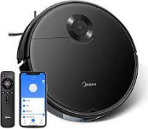  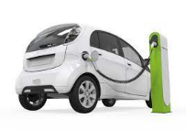  When looking at real-life examples, children will be shown modern, state of the art examples that they may not see often, or at all, in Cornwall. | Building on the examples they will have seen each year, children in UKS2 will be more aware of the part that economies play on the Design Technology world and why some places have more modern technology than others.
 | Vocabulary Gap | Cutting, folding, joining  Chopping  Peeling  Hinge, open, close  Structure, strong, weak | cut, fold, join, fix, slider, lever, pivot, slot, bridge/guide  assembling, shaping, finishing, free, moving, template, pattern pieces, mark out, decorate, finish  slicing, peeling, cutting, squeezing, blending, healthy diet ,  sensory vocabulary e.g. soft, juicy, crunchy, sweet, sticky, smooth, sharp, crisp, sour, hard | mechanism, lever, linkage, pivot, slot, bridge, guide system, input, process, output  fabric, fastening, strength, weakness, stiffening, stitch, fabric glue, pins, measuring tape  accuracy, material, stiff, strong, reduce, reuse, recycle  knives, chopping board, weighing scales, measuring jugs, bowls, baking trays, hygienic, edible, grown, reared, caught, frozen, tinned, processed, seasonal, harvested healthy/varied diet | frame structure, stiffen, strengthen, reinforce, triangulation, stability, shape, join, temporary, permanent  seam, seam allowance, wadding, reinforce, right side, wrong side, hem, template, pattern pieces  insulator, conductor, crocodile clip, circuit, switch, circuit diagram annotated drawings, exploded diagrams mechanical system, electrical system, input, process, output  fat, sugar, carbohydrate, protein, vitamins, nutrients, nutrition, healthy, varied, gluten, dairy, combine, fold, knead, stir, pour, mix, rubbing in, whisk, beat, roll out, shape, sprinkle,
 | Oracy and articulating their own opinions | Children will say what they want to make and may describe what they have made. | Children will say what they want to make and how they want to make it. They will begin to test real-life products and given their own opinions. | Children will decide what product they want to make, who it will be for and what it’s usage will be. They will begin to choose their own materials and explain why they have made their choice. They will have experience of using real-life products and giving their opinions. | Children will be able to articulate how they want to make their product, what materials they will use and why and why they think it will be the best. They will also have to critique and evaluate their products and real-life examples so will be articulating their own opinions in every step.
DT Concepts | Creative, technical | Explorative play and problem solving throughout continuous provision. | Children encouraged to problem solve in their learning and confidently express their own ideas. | Children use materials and complete tasks confidently. | Children will perform everyday tasks confidently and participate successfully in an ever increasing technological world.
 | Build and apply | Opportunities to use construction kits to create their own ideas. | Children will be able to use construction kits and other materials to create what they want to make. | Children will be able to create prototypes and products using a growing technological knowledge about what materials may be best. | Children will have technological knowledge, understanding and skills to create high-quality prototypes and products.
 | Critique, evaluate and test | Opportunities to play with and use toys, construction kits etc. | Children will have an idea that things have been created with a particular purpose. | Children will use things with a purpose in mind and begin to explain if they could use something else, whether the product has helped them complete the task or if it could be improved. | Children will be able to test theirs, and others, ideas and products.
 | Principles of nutrition | Children will know that food can be healthy and unhealthy. | Children will know that everyone should eat at least five portions of fruit and vegetables a day. | Children will know that a healthy diet is made from a variety and balance of different food and drink and that food and drink are needed to provide energy for the body. | Children will know that different food and drink contain nutrients, water and fibre that are needed for health.
 | Consequences and impact 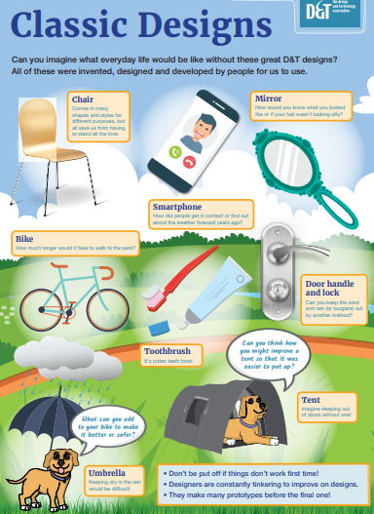 | Children will know there are differences between how they live now to how people used to live. | Children will begin to understand that the technology we use today has been developed and was not always around. They will begin to understand that people lived without the technology they see every day. | Children know that technology has been developed and it has not always been around. Children will know that people used to live without electric and the impact that the discovery of this has made on the world. | Children know that technology has changed our lives and that there was a time before the technology of today.
DT Skills - Designing | Understanding contexts, users and purposes | Say what they want to make and why they want to make it. | Use simple design critera; state what their products are, who and what they are for and how they will work. | Gather information about user needs; develop their own design criteria; describe the user, purpose and design features of their products and explain how they will work. | carry out research; develop a simple design specification; describe the user, purpose and design features of their products and explain how they will work
 | Generating, developing, modelling and communicating ideas. | Talk about what they want to make, discuss products they’ve used before. | Generate ideas using their own experiences and existing products; use talk, drawing, templates, mock-ups and, where appropriate, computers. | Generate realistic ideas based on user needs; use a range of drawing skills, discussion, prototypes, pattern pieces and computer-aided design. | Generate innovative ideas drawing on research; use a range of drawing skills, discussion, prototypes, pattern pieces and computer-aided design.
DT Skills – making | Planning | Say what they want to make before they make it. | Plan by suggesting what to do next; select from a range of tools, equipment, materials and components. | Order the main stages of making; select suitable tools, equipment, materials and components and explain their choices. | Formulate lists of resources and step-by-step plans; select suitable tools, equipment, materials and components and explain their choices.
 | Practical skills and techniques | Begin to use equipment safely. | Follow procedures for safety and hygiene; measure, mark out, cut, shape, assemble, join, combine and finish a range of materials and components. | Follow procedures for safety and hygiene; use a wider range of materials and components; measure, mark out, cut, shape, assemble, join, combine and finish with some accuracy. | Follow procedures for safety and hygiene; use a wider range of materials and components; measure, mark out, cut, shape, assemble, join, combine and finish with accuracy.
DT Skills - evaluating | Own ideas and products | Say if they like their design and anything they would like to improve. | Make simple judgements about their products and ideas against design criteria. | Evaluate their ideas and products against their design criteria. | Identify strengths and areas to develop in their ideas and products against their design specification; consider the views of others to make improvements.
 | Existing Products | Discuss products they have used and what they like and dislike about them. | Explore who and what products are for, how they work and are used, what materials they are made from and what they like and dislike about them. | Investigate how well products have been designed and made, whether they are fit for purpose and meet user needs; why materials have been chosen, the methods of construction used and how well they work. | Investigate how well products have been designed and made, whether they are fit for purpose and meet user needs; why materials have been chosen, the methods of construction used, how well they work, and how innovative and sustainable they are.
 | Key events and individuals |  |  | Know about inventors, designers, engineers, chefs and manufacturers who have developed ground-breaking products. | Know about inventors, designers, engineers, chefs and manufacturers who have developed ground-breaking products.
DT Skills – technical knowledge | Making products work | In continuous provision children have the opportunity to play with and explore mechanisms, for example, toy cars. | Know about the simple working characteristics of materials and components, the movement of simple mechanisms, how freestanding structures can be made stronger, stiffer and more stable; use the correct technical vocabulary. | Know that materials have functional and aesthetic qualities; that systems have an input, process and output; how to program a computer to control their products; how to make strong, stiff shell structures; use the correct technical vocabulary. | Know that materials have functional and aesthetic qualities; that systems have an input, process and output; how to program a computer to control and monitor their products; how to reinforce and strengthen a framework; use the correct technical vocabulary.
DT skills – Cooking and nutrition | Where food comes from | Experience of different types of food ie. fruit and vegetable. | Know that food comes from plants or animals and that it is farmed or caught. | Know that food is grown, reared and caught in the UK, Europe and the wider world. | Know that food is grown, reared and caught in the UK, Europe and the wider world; that seasons may affect the food available; how food is processed into ingredients.
 | Food preparation, cooking and nutrition. | Begin to prepare simple dishes safely and hygienically. Know that the food we eat can be healthy or unhealthy. | Know how to prepare simple dishes safely and hygienically without a heat source, name and sort foods into groups; know that everyone should eat at least five portions of fruit and vegetables a day. | Know how to prepare a variety of dishes safely and hygienically; that a healthy diet is made from a variety and balance of different food and drink; that food and drink are needed to provide energy for the body. | Know how to prepare and cook a variety of dishes safely and hygienically using, where appropriate, a heat source; that different food and drink contain nutrients, water and fibre that are needed for health.

Curriculum Map Product User Purpose
YR | Hunting for structures – EYFS  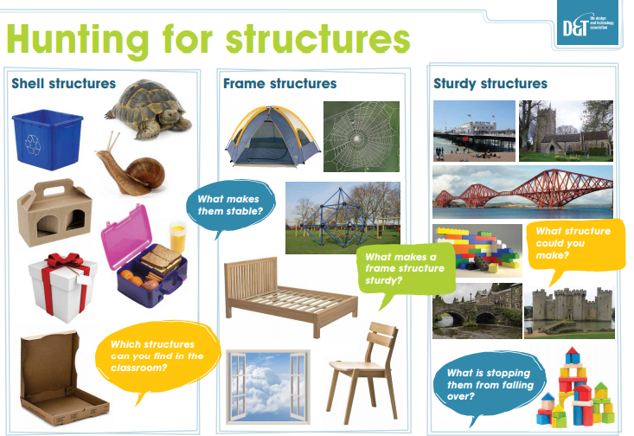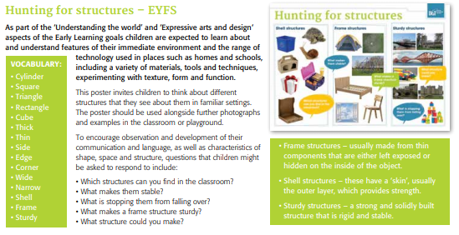  Design, make and evaluate a strong wall for humpty dumpty for sitting on safely. (construction kit) | Going on a joint hunt – mechanisms Design, make and evaluate a class storybook for the other Reception class about their interests and hobbies.  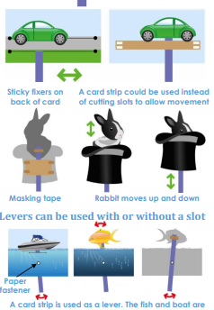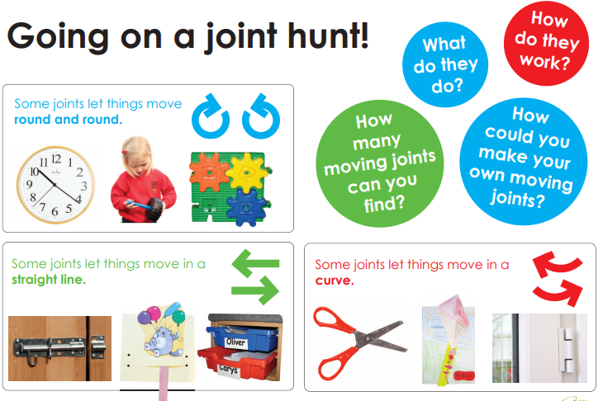 | Textiles  Design, make and evaluate a picnic blanket for the three little bears to take on a picnic with Goldilocks. | Food  Design, make and evaluate a fruit salad for themselves for a class picnic.

Y1 | Covid catch up (yr R topic)  Design, make and evaluate a strong wall for humpty dumpty for sitting on safely. (construction kit) | Mechanisms  Wheels and Axles  Design, make and evaluate a trolley/wheelbarrow for a character in a story to carry vegetables in from the field. | Structures  Free standing structures Design, make and evaluate a chair for a teddy to sit on. (reinforcing materials, strengthening materials etc) | Textiles  Design, make and evaluate some class bunting for a summer picnic for Dr Cook. | Food  Preparing fruit and vegetables  Design, make and evaluate a fruit kebab for their friends to eat at sports day.

Y2 | Mechanisms  Sliders and levers  Design, make and evaluate a greetings card for a family member for Christmas. | Food  Preparing fruit and vegetables  Design, make and evaluate a healthy fruit smoothie for their peers to celebrate healthy eating and a healthy lifestyle. | Structures  Design, make and evaluate a kite for themselves to fly on the school field. | Textiles  Templates and joining techniques  Design, make and evaluate a glove puppet to perform a play for the children in reception.  Basic sewing stitch

Y3 | Mechanical Systems  Levers and linkages  Design, make and evaluate a moving card for a younger pupil to give them information about insects.  Eg. moving pictures of bees to flowers, butterflies to flowers etc.  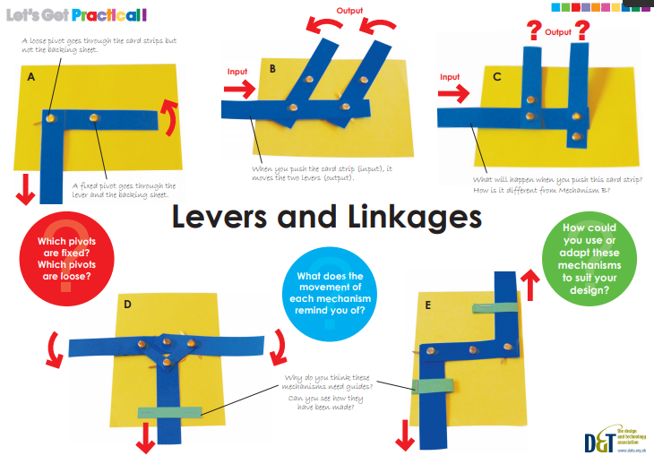 | Structures  Design, make and evaluate a desk tidy for themselves to use in the classroom. | Mechanical systems - Pneumatics  Design, make and evaluate a pneumatic toy for a friend for their birthday present.  Design a monster/beast to protect the classroom?? | Textiles  - covid catch up y2 topic.  Time to practise and consolidate sewing techniques.  Templates and joining techniques  Design, make and evaluate a glove puppet to perform a play for the children in reception.  Basic sewing stitch | Electrical systems  Design, make and evaluate a night light for themselves or a younger sibling to help them get to sleep at night.  Children will need a very basic understanding of electrical circuits. | Food  Healthy and varied diet  Design, make and evaluate a healthy wrap for themselves for a picnic (school trip?)

Y4 | Covid catch up, levers and linkages  Design, make and evaluate a birthday card to celebrate the birthday of a friend or family member. | Structures  Shell structures  Design, make and evaluate a gift box for a friend or family member for a Christmas present. | Mechanical systems- Pneumatics  Mighty mascots  Design, make and evaluate a moving mascot for their class for sports day. | Food  Design, make and evaluate a healthy dip for guests at a party. | Textiles – Textiles  2D shape to 3D product  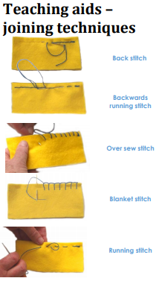  Design, make and evaluate a purse or wallet for a family member to use and keep their money safe. | Electrical Systems  Simple circuits and switches (including programming and control)

Y5 | Covid catch up, levers and linkages  Design, make and evaluate a Halloween card for Halloween for a friend. | Food  Design, make and evaluate a festive ginger biscuit to give away at Christmas. | Mechanisms  Design, make and evaluate a sign with a message for a chosen audience to remind them about something.  Ie, a moving picture of rubbish going into a bin to remind the public to recycle.  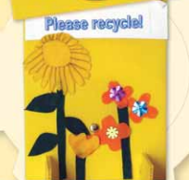 | Textiles  Covid catch up –  Y4 topic  Design, make and evaluate a purse or wallet for a family member to use and keep their money safe. | Structures  Frame structure  Design, make and evaluate a bird hide for a bird watcher. | Electrical Systems  Monitoring and control  Crumble  Develop a design specification for a product that responds automatically to environmental changes in the environment. • Generate and communicate ideas through annotated sketches and representations of electrical circuits or circuit diagrams. • Using a step-by-step plan, select and accurately assemble materials, electrical components, to produce a functional product. • Create and modify a computer control program to enable their electrical product to respond to changes in the environment.

Y6 | Covid catch up, levers and linkages  Design, make and evaluate a card for a chosen purpose for a chosen audience. | Textiles  Combining different fabric shapes including CAD  Design, make and evaluate a fabric advent calendar for themselves to celebrate the Christmas season. | Mechanical Systems Pulleys, gears or cams/  Design, make and evaluate a moving toy for a shop window display in a toy shop. | Structures  Design, make and evaluate a marble run game for themselves to play with during golden time. | Electrical systems – alarming vehicles  Design, make and evaluate a car which is alarmed to prevent theft for a parent/ teacher. | Food  Celebrating culture and seasonality  Design, make and evaluate a savoury biscuit for parents for parents’ evening.

Famous people:
Children should know a range of inventors, what they are famous for and what made them become successful.
Famous chef: Paul Ainsworth

- Who they are? Chef in Padstow
- What they are famous for? Head chef at a restaurant, famous for using local produce and what is in season.
- What made them successful? chef
Paul Ainsworth

Famous designer: Charles Worth

- Who they are? first ‘fashion designer’ in the 19th Century
- What they are famous for? English fashion designer who created dresses for individuals.
- What made them successful? He was popular – he made outfits in France and previously outfits had just been bought by people but he would make them to fit his client in a material chosen by them.
Charles Worth

Famous inventor: Garrett Morgan
- Who they are?
- What they are famous for? Designing a revamped sewing machine which meant clothes could be manufactured quickly.
- What made them successful?

Children should explore some famous engineers who have made strong structures – Isambard Kingdom Brunel, possible Stephen Sauveste who designed the Eiffel Tower.
- Who they are ?
- What they are famous for ?
What made them successful?

Famous chef: Heston Blumenthal

- Who they are?
- What they are famous for? Famous Chef known for adapting recipes and being a quirky cook.
- What made them successful? Three Michelin stars (one of only five restaurants in the UK)
Heston's inventive chocolate waterfall

Famous inventor: Benjamin Franklin

- Who they are ? started exploring electricity in 1746
- What they are famous for ? He did lots of experiments and investigations about static electricity.
- What made them successful?
He was the first to label ‘positive’ and ‘negative’ charge.

Famous inventor: Lewis Urry

- Who they are? Canadian
- What they are famous for? Chemical Engineer and inventor
- What made them successful? Invented the alkaline and lithium battery.
Enigizer Battery Advert

Famous designer: Elspeth Champcommunal

- Who they are?
- What they are famous for? British fasion designer during the war and first editor of British Vogue magazine.
- What made them successful? Designing clothes that could be made by people at home to keep spirits up during the war. This meant clothes without extra pockets, pleats and turn-ups as these were deemed too extravagant.

Structural Project – yr 6
Windmill – based on the book ‘The boy who harnessed the wind’.

Creating a waterproof, strong structure that moves water based on a cross-curricular topic on the ‘Boy who harnessed the wind’.

Inventor: William Kampwamba

- Who they are? At the time a 14 year old boy from Malawi whose family couldn’t afford to send him to school. He read books from the library about electricity and made a windmill in his village.
- What they are famous for? Designing and making a windmill that would give electricity to his house and help water the crops and provide water for his village.
- What made them successful? In the height of a drought in Malawi, William saw a need and made a windmill. He powered a small lamp in his bedroom to begin with, then his house and whole village. The houses in the village are also able to pump water for the village’s fields and houses.
The William Kampwamba story

